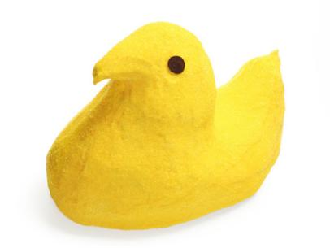
Bedford Free Public Library’s
8th Annual Peeps®
Diorama Contest
Official 2018 Entry Form

Name (or Team): _________________________________________________________

Email (or Phone): _________________________________________________________

Title of Diorama: _________________________________________________________

Age category (check one): Grades K-5 Grades 6-12

Family (mixed ages)/Adult

Was this a group project? Yes No

If so, list the names of your group members:

_____________________________________________________________________

_____________________________________________________________________

The Rules
- Peeps® must feature prominently in your diorama.
- Limit one submission per individual/team contestant.
- Your finished work must not be larger than 2 feet wide by 2 feet deep.
- You must submit a completed copy of this form with your entry.
(Available at the library or www.bedfordlibrary.net/teens/peeps-diorama-contest/)
- Entries must be submitted by 8PM on Tuesday, March 20th. Late entries cannot be accepted.
- Submitted entries will be displayed in public. The Library takes no responsibility for damage.

The Awards
- The public is invited to view entries on display in the Library from Wednesday March 21 through Tuesday March 27 and to cast their votes for our "Peeple's Choice" Award.
- Other honors shall include the coveted “Best in Class” award for each age category.
- Winners will be announced on Wednesday, March 28 at our 2:30PM Awards Show.
(Held at the Library. Contestants, Peeps® enthusiasts, and national press are invited.)
- Entries must be claimed by Tuesday, April 3rd at 6:00 pm; or else, they’ll be eaten!

